Explorer’s Map Directions
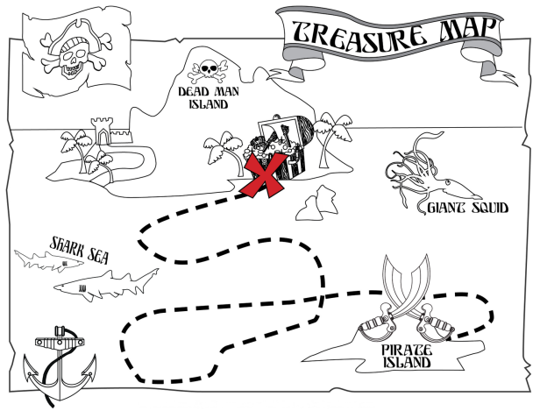
Due Thursday, Nov. 20, 2014

- Map -Using an atlas or online resource as a guide, you will draw a map of the area where your explorer explored which includes the following details:
- Title (5pts)
- Compass Rose including cardinal directions (5 pts)
- Map Key (20pts)
  - Date(s) of voyage or expedition
  - Symbols showing route(s) (If you are showing multiple routes, you should use a different colors for each.)
  - Land claimed for your country (if applicable)
- Route (60 points)
- Shows where the journey began and ended.
- Drawn in color
- Arrows showing directions traveled
- Areas of land claimed by your explorer (if he claimed land).
- Label all areas he explored including land, oceans, rivers, and lakes.
- Label cities or places where his journey began and where he stopped along the way.
If your explorer went on more than one voyage or expedition, you must draw the most important route. You may draw all of his routes if you choose to.
- Creativeness (10 Points)
  - Old maps often included many pictures which showed things sailors feared while at sea. Include at least 2 pictures which represent their fears. (You must draw your own pictures.)
  - Your map should be neatly colored and easy to read. To get ideas, look at some of the colorful maps on my website.
  - Aging your map will help to make it look old.

Total Points for Map: 100

