Shoe Box Pirate’s Treasure Chest Instructions

Here is just one way you can make your treasure chest. Go to my website to see others.

Supplies

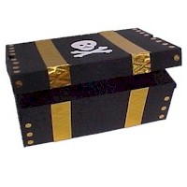
Shoe Box with Attached Lid

Black Paint & Brush
Embossing Foil
Paper Fasteners
Skull Printable
Glue & Scissors

Instructions

- Paint the box black. Let dry.

- Cut strips of foil and glue on to box.

- Poke fasteners into the box for more decorations.

- Cut out the skull below. Glue to box.

